**Session 7**

**-**

**ADC and UART serial communication**

**Author:** Guillermo Cortés Orellana

**Teacher:** Tomáš Frýza



Lab assignment

1. **Preparation tasks**

* Table with voltaje divider, calculated and measured ADC values for all buttons

|  |  |  |  |
| --- | --- | --- | --- |
| Push button | PC0[A0] voltage | ADC value (calculated) | ADC value (measured) |
| Right | 0 V | 0 | 0 |
| Up | 0.495 V | 101 | 101 |
| Down | 1.2 V | 245 | 245 |
| Left | 1.96 V | 401 | 402 |
| Select | 3.18 V | 650 | 650 |
| None | 5 V | 1023 | 1022 |

1. **ADC**

* Listing of ADC_vect interrupt routine with complete code for sending data to the LCD/UART and identification of the pressed Button

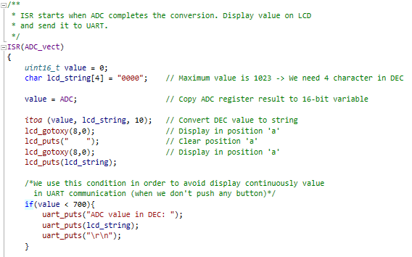

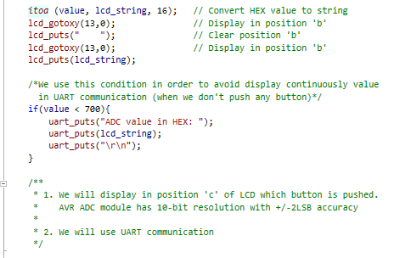

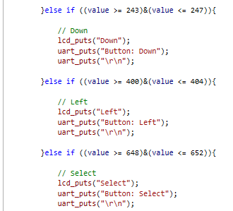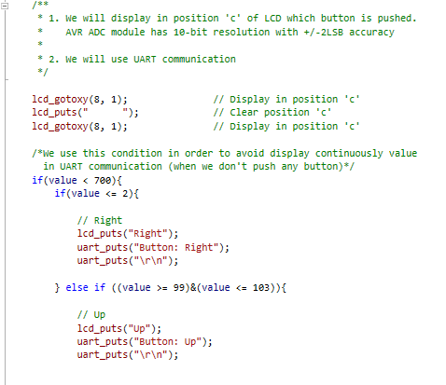

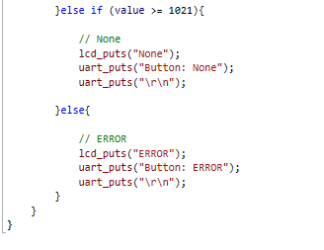

You can find the code on my GitHub:

https://github.com/GuicoRM/Digital-Electronics-2

* Screenshot of SimulIDE circuit when “Power Circuit” is applied

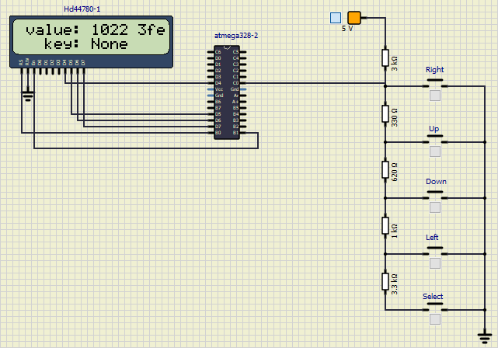

1. **UART**

* (Hand-drawn) picture of UART signal when transmitting data DE2 in 4800 7O2 mode (7 data bits, odd parity, 2 stop bits, 4800 Bd)

If we consider 4800 Bd → TBIT = → **TBIT = 208 us**

**DE2 = 100 0100 – 100 0101 – 011 0010 (with 7 bits)**

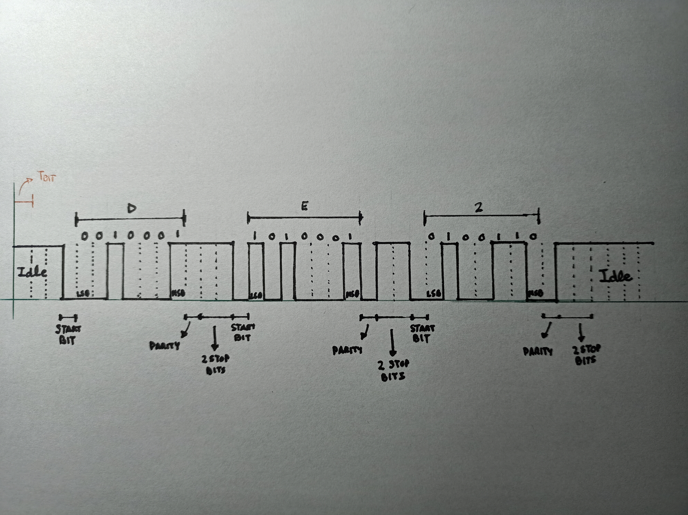

* Listing of code for calculating/displaying parity bit

I couldn’t find out the solution of the code. I have several ideas about how to solve it but I don’t know how to codify them.

1. We could work with frame data
2. We could work with the variable ‘value’ which is equals to ‘ADC’ in order to count the number of ‘1’ and ‘0’ and find out the parity
3. We could solve the problem working in rudimentary way which only would be valid for this example: first, we could display different values of voltage; secondly we could count the number of ‘1’ and ‘0’ and finally decide if we chose odd or even parity and display it